Dear Overseas Buyers:

We would like to introduce you a cool and useful design, and it is an amazing fashionable machine for everyone who wants a better life. Whatever the client is children or elderly, this powerful two-in-one humidifier is the best choice ever!

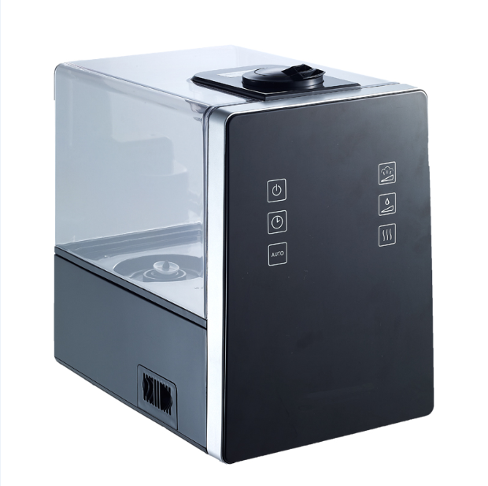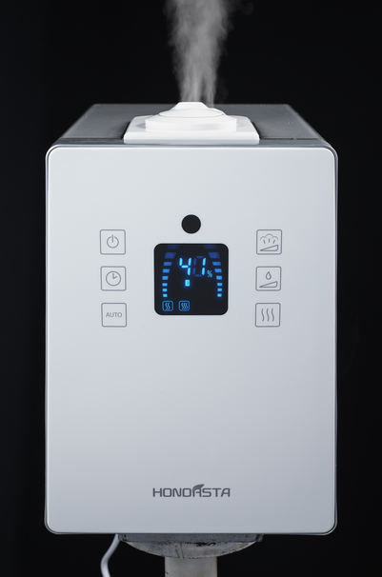

Combination of atomization and gasification, a patent technology, offers users various mode with appropriate temperature in different seasons. Luxury LED display, high-tech keyboard, three adjustable humidifying levels, and AUTO humidity setting for comfortable R.H. Besides, high standards of raw materials, good-quality of ceramic membrane of atomizer, and automatic shut-off function are used to resist water scale efficiently, avoid damage, and prolong the using life.

**Description of 2 in 1 Air Humidifier**

|  |  |
| --- | --- |
| Type | Ultrasonic Humidifier |
| Installation | Tabletop |
| Power | 280W |
| Voltage | As Customer Request |
| Mist rate | Cool mist>250 ml/h;Warm mist>550 ml/h |
| Humidity Control | Digital |
| Color | According to your requirement |
| Certification | CE,ROHS,UL,EMC,ETL |
| Others | Low noise less than 45dB when working;  Bactericidal function with 100℃ high temperature of water;  Supporting 12 hrs time setting;  360 degree rotatable mist nozzle |

If you want to get quotes and other details of this awesome two-in-one humidifier, please contact us by e-mail, and we will reply you as soon as possible. Thank you.

Sincerely,